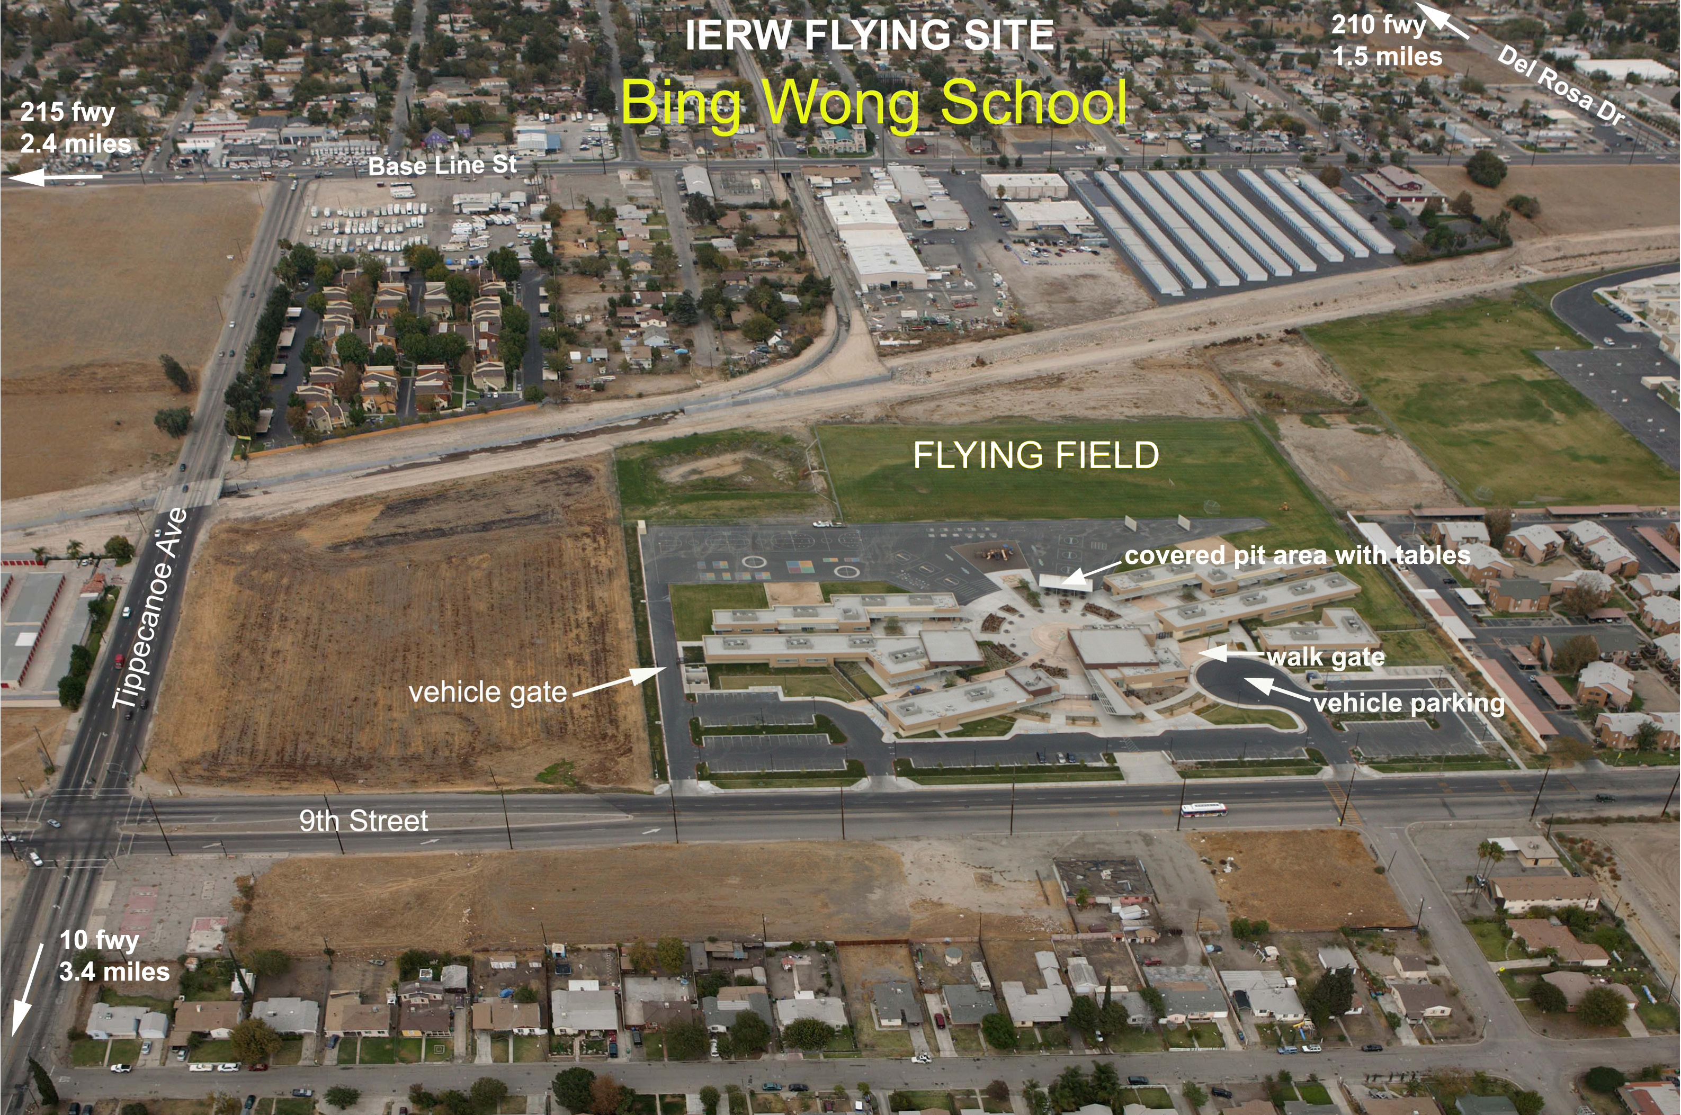

The Inland Empire Rotor & Wing Club was established in 1988. The Club field is at Bing Wong School in San Bernardino, (34° 6’ 59” N - 117° 15’ 28” W). The field address is 1250 9th St, San Bernardino, CA 92410.
Our field is grass and blacktop with a covered pit area. The field is open from 9:00 AM to dusk on Sundays.
We fly helicopters, airplanes, and drones, nitro, electric, park flyers, etc. Everyone is welcome to come and watch, current AMA is required to fly.
Non club members are welcome to fly free as guests. Help is always available. Annual club membership is $20.00.

Contact: IERWflyers@yahoo.com 